VĂN LANG UNIVERSITY
INFORMATION TECHNOLOGY DEPARTMENT

Software Measurement & Analysis

Team: 01
Class: K15T1
Members:
Name | ID
Lê Thị Bích Vân | T09
Đỗ Minh Tâm | T09
Lê Đình Thạch Huyên | T097590
Đặng Huy Sơn | T094967
Nguyễn Trung Tín | T097676

Table of Content

1. Introduction 2
2. The process of team 2
3. Team roles and responsibility 3
4. Meeting Schedule 5

  - Introduction
- The purpose of this document is to provide a brief summary of the regulations of the cooperation of this team and outlines its basic activities.
- This team has been created to work collectively on Software Measurement and Analysis course.
- The process of team.
- Team roles and responsibilities.
- Schedule.
  - The process of team
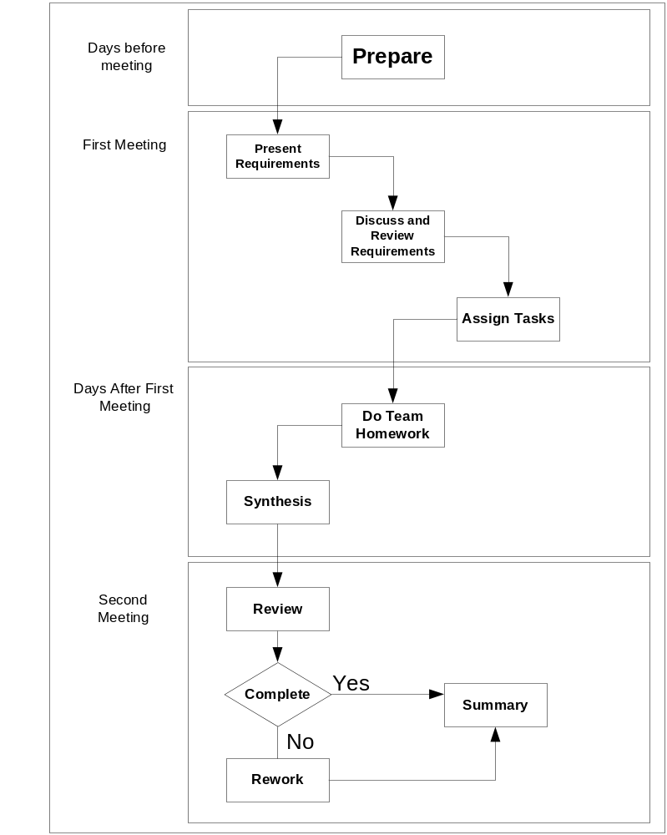

Steps | Description
Prepare | In first step, team member whom is assigned task to analysis team assignment title will preview problems in assignment.  Have to compose and delivery objects of meeting, problems need to discuss and tasks will give to each member in assignment.
Present requirement | Team member whom is assigned task to analysis team assignment title have to present the objects of meeting, problems and tasks to do for his/her team.
Discuss and review | Everybody in team will discuss the giving problems in previous step. Review objects of team assignment and tasks to do.  Everybody will modify objects and tasks to do together in this meeting after discussion.
Assisgn tasks | Team leader will assign works for each people.
Do Team homework | Team members will complete their works at home and send them to sub-leader.
Synthesis | Sub-leader will collect and integrated, preview final document and prepare to present.  Sub-leader sent final version to leader to pre-review.
Review | In this meeting, everybody will review and ensure assignment was finished. Documents were completed and check spelling errors.
Rework | If detect problems in documents, everybody will discuss and solve it in this meeting.
Summary | Team leader collect effort logs of people, get lessons learned together and improve process for next assignment.  After meeting, leader evaluate team members effort and submit.
  - Team roles and responsibility

Role | Responsibility | Name
Director (constant) | - Owner of the overall business change that is being supported by team assignments. | To Dinh Hieu
Leader (constant) | - Planning and then assigns the activities for each of the team members. In the meeting, all of the members of the team should have been assigned their workload.  - Creates and maintains project plan  - Ensures tools and methodologies are being adhered to Reports status  - Preparing for two meetings. If necessary, Team Leader can conduct the meeting on Saturday at 1.00 pm for updating final of team assignment.  - Monitor: Prepare and after meeting. Oversees day-to-day operations.  - Review: effort log of each member  - Evaluate the work of its members.  - Team Leader will also prepare the Power Point slides as outlined in the presentation. | Le Thi Bich Van
Sub-Leader | - Support Leader analysis of the main requirements and prepare an agenda for the meeting and post it on the team website. After the meeting has been conducted, the results of the meeting must be posted on the website.  - Internal documentation and system documentation  - Provide resources  - Support Leader will have received completed parts of the assignment from other members of the team. He will then combine the whole Assignment and release (send it by email to all the members of the team and put it on the Team website) the draft of the assignment on Tuesday.  - Team will then comment on the whole assignment. It is a responsibility of the Team Leader to submit the Assignment on the due date of the assignment using the submission server at https://hoctructuyen.vanlanguni.edu.vn/course/view.php?id=343 | Le Dinh Thach Huyen
Members | - Record effort log every day.  - Do teamwork, team member must complete their assigned works on time.  - Read documents before the first meeting every assignment  - Make presentation file | Dang Huy Son  Do Minh Tam  Nguyen Trung Tin
Recorder (constant) | - Integrate effort log every week  - Record meeting minutes every meeting | Do Minh Tam

  - Meeting Schedule
- The following dates represent the meeting schedule for team per week:
- Monday – at 10:30 am
- Wednesday – at 10:30 am to
- May be Saturday – at 10:30 am to 1.00 pm. See the section 3 to understand content in each meeting.
- References attachment: “Schedule_K15T1_Team1”

